Lean Value Stream Mapping Project at Farm Equipment International

# Objective:

This report documents the Lean Value Stream Mapping project conducted at Farm Equipment International (FEI) to optimize the manufacturing processes for hydraulic control sections. The project aims to analyse the current manufacturing process, identify areas for improvement, and propose a future state design aligned with Lean manufacturing principles. Additionally, an implementation plan will be developed to facilitate the transition from the present state to the future state.

# Introduction:

Farm Equipment International (FEI) operates in the agricultural sector, specializing in the production of components and sub-assemblies for agriculture equipment. This report presents the findings and recommendations of a Lean Value Stream Mapping project conducted to enhance the manufacturing processes for hydraulic control sections at FEI.

The production of hydraulic control sections involves several complex processes, including cutting, welding, painting, assembly, and machining. Due to the wide variety of configurations and the dynamic nature of customer requirements, FEI faces challenges in maintaining efficiency and meeting delivery deadlines.

The primary objective of this project is to analyse the current manufacturing process for hydraulic control sections and identify opportunities for improvement. By applying Lean principles and Value Stream Mapping techniques, the project aims to streamline operations, reduce waste, and enhance overall productivity.

Through a thorough examination of the current state processes and an evaluation of future state design options, this report will provide actionable insights and recommendations for FEI to optimize its manufacturing operations. Additionally, an implementation plan will be proposed to guide the company in transitioning from the present state to the future state, ensuring sustainable improvements in efficiency and performance.

Overall, this project represents a strategic initiative to leverage Lean principles and enhance competitiveness in the agricultural equipment manufacturing industry. By systematically analysing and improving its manufacturing processes, FEI can achieve operational excellence and deliver greater value to its customers.

# **Current State of FEI.**

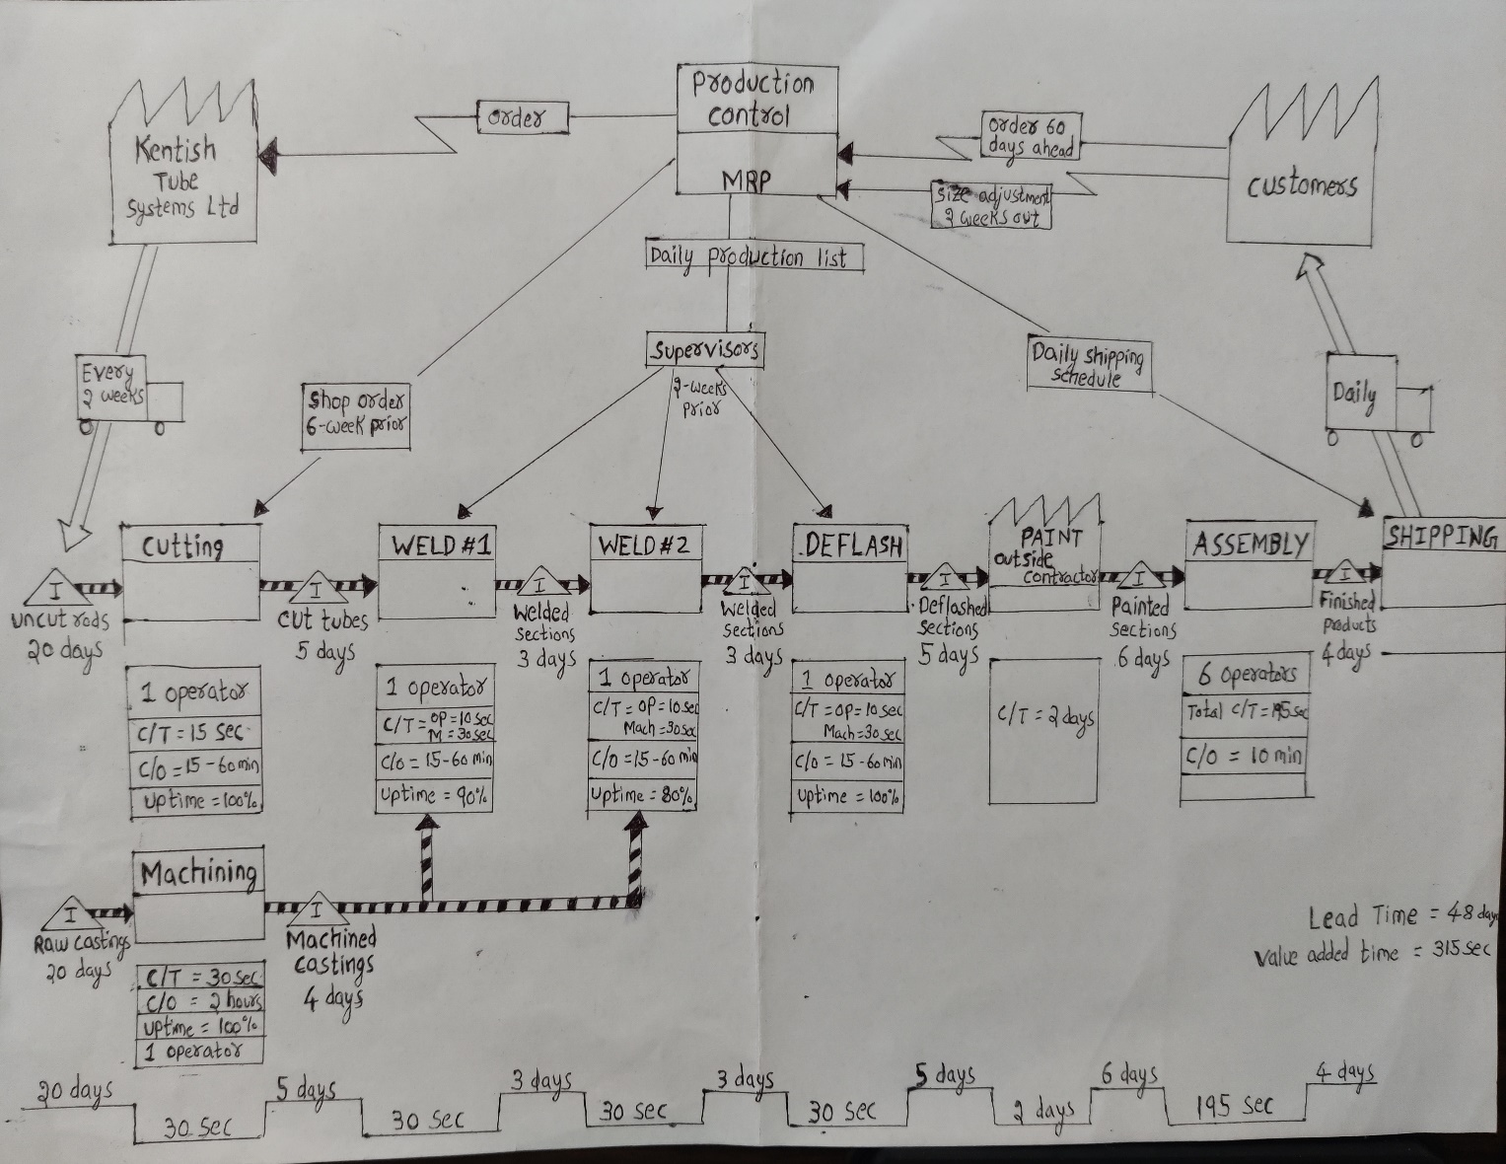

## The key questions that define the future state design.

1. **TAKT time for FEI product family?**

The working time per shift in FEI’s timetable is 8 hours. And, it has two 15-minute breaks per shift. So, the total available working time per shift is 7 hours 30 minutes, which is 27000 seconds. The customer demand is 24000 sections per month. FEI has 20 working days per month.

24000 /20 = 1200

So, FEI need to produce 1200 sections per day or 600 sections per shift to meet the customer demand.

TAKT time = Available working time/customer demand

= 27000/600

= 45 seconds.

The takt time of FEI is 45 seconds, so it needs to produce a unit section for every 45 seconds to meet its customer demand.

1. **Should FEI build hydraulic control sections to shipping?**

As the customers of FEI changes the configuration requirements of hydraulic control sections very often, it is very difficult to build and store the products for supermarket. So, FEI should directly need to produce the products for shipping to maintain smooth flow of production.

1. **Where can FEI introduce continuous flow?**

As the cycle time is same for the two welding processes and the Deflash process, they can be merged as a continuous flow. And we can introduce FIFO flow from welding to paint and then to assembly making it a continuous flow. So, the processes from welding to shipping are in a continuous flow. The upstream processes cutting and machining have different cycle times, so it is difficult to add a continuous flow there.

1. **supermarket pull systems for FEI?**

We can make the supplier to deliver the raw material weekly instead of every 2 weeks. By this, we can start the production after receiving 2 weeks forecast of exact order specification. So, Super Market Pull system can be introduced before cutting and machining process. 7 days-worth of raw materials are stored in the super markets. Kanban’s are attached to the materials in the supermarket. When the materials are withdrawn from the supermarket, the associated Kanban’s are sent to production control to place the order and replenish the raw materials.

Supermarket Pull Systems can also be introduced after cutting and machining process, ahead of continuous flow of welding and deflash processes. 1 day worth of cut and machined materials can be stored in these supermarkets. Withdrawal Kanban’s are used to draw the material from supermarkets according to the requirements of production processes. Then, production and signal Kanban’s are sent to cutting and machining processes to replenish the finished goods in the supermarket. As the machining process has large changeover time a signal Kanban is used to alert the machining processes which types of products need to be produced by the process.

1. **Point of introducing pacemaker process.**

FEI should schedule the pacemaker process at WELDING + DEFLASH process. It is not possible to schedule the pacemaker process further upstream, as cutting and machining processes need to produce products with different specifications and store them in supermarket. And also, the pacemaker process should be introduced at a point after which there should be a continuous flow until the customer.

1. **FEI’s production mix at the pacemaker process?**

To produce products with different specification, The production process in the FEI should undergo frequent changeovers of tools. The changeover time of some processes can be large. At the same time, we cannot produce the products in batches which in turn increases the lead time of entire process system. So, to level the production mix at the pacemaker process, FEI need to decrease the changeover times of the processes by keeping all the required tools near the operator to enable fast changeover between products.

1. **Work increment and TAKT time at pacemaker process.**

As the exact customer requirements can only be received 2 weeks prior to shipping, we started the production process after receiving that exact order. In order to cover the different specifications of orders, FEI need to introduce load levelling of production mix and so releases orders at the pitch increment.

Pitch = Takt time * Pieces/box

= 45 * 50

= 2250 seconds

= 37.5 minutes.

So, the production control of FEI releases the orders at a pitch increment of every 37.5 minutes to maintain the production mix of diversified products.

1. **Required process improvements for FEI.**

The necessary improvements are:

* Reduce the inventory before the cutting and machining process to 7 days.
* Minimizing the change-over times in cutting and machining process to provide fast changing between producing different specified products.
* Eliminating waste by decreasing man power in welding and machining processes from 3 operators to 2 operators. (As the total cycle time is 90 seconds and the takt time is 45 seconds, 2 operators will be sufficient)
* Improvement in on-demand uptime of pacemaker processes to 100%.
* Decreasing the number of operators in assembly process from 6 to 5. (Total cycle time is 195 seconds and takt time is 45 seconds).
* Achieved a decreased lead time.

# **Ideal Future state design for FEI.**

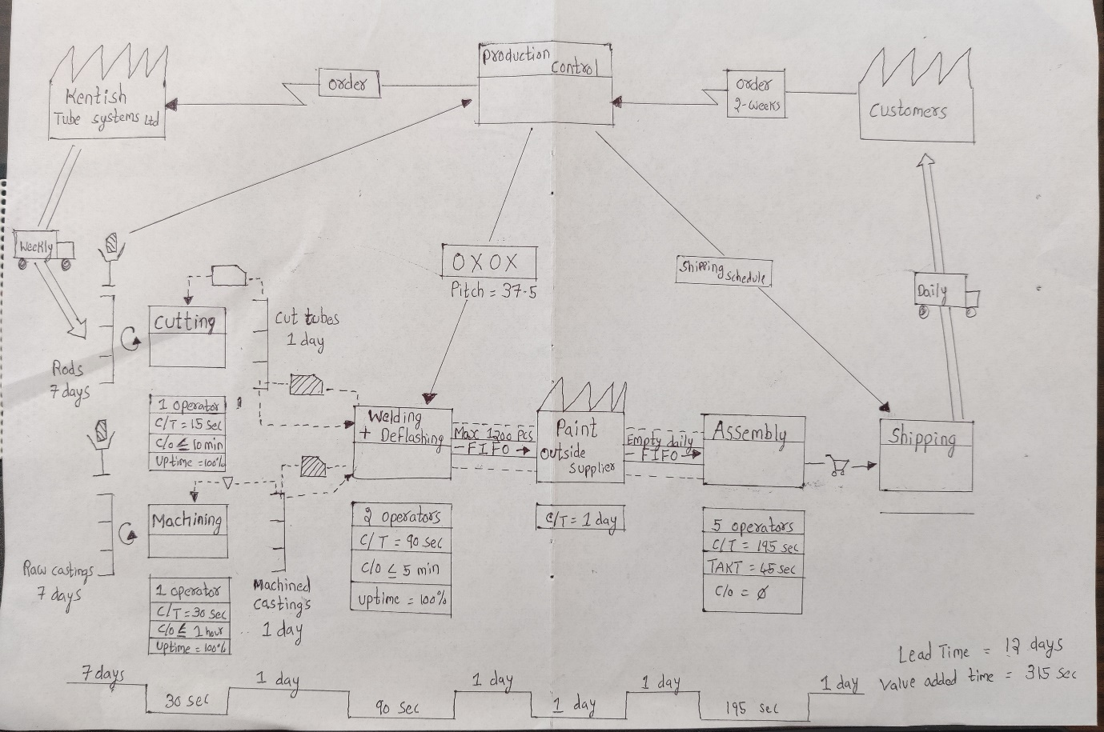

1. **Plan for moving the company to future state.**

At the pacemaker loop:

* Achieve continuous process by combing welding and Deflashing processes.
* Extend this continuous process to shipping by introducing FIFO processes between pacemaker and paint, by sending only 1-day requirements of customer from pacemaker to paint. And also, introduces FIFO between paint and shipping. The painted products are directly sent to assembly and then to shipping by an operator.
* Decrease the labour from 3 to 2 operators. As the cycle time is 90 seconds and takt time is 45 seconds, 2 operators can finish the job.
* Decrease the changeover time at welding and assembly stations, by keeping all the materials required to change the specifications of the product, near operators.
* Increase the on-demand uptime to 100% at pacemaker process.

AT Cutting and Machining process:

* Introduce super-market pull systems ahead of cutting and machining processes.
* Attaching withdrawal Kanban’s to materials in supermarket to replenish the inventory.
* Keeping an inventory of 7 days in the supermarket ahead of cutting and machining processes.
* Introducing super-markets with 1-day inventory after cutting and machining processes
* Attach production Kanban to supermarket after cutting and signal Kanban to supermarket after Machining, to replenish the materials.
* Also, attach withdrawal Kanban’s between supermarket and pacemaker process.

At supplier:

* Make the supplier to send shipments weekly.
* Make the supplier to send 7 days requirement of raw materials.

References

* Rother, Mike. Shook, john. (1998). Learning to see: Value stream mapping to add value and eliminate Muda. Brookline. Lean Enterprise institute. Available at: Drill Hall Library.